**DAILY ONLINE ACTIVITIES SUMMARY**

|  |  |  |  |  |  |  |  |  |
| --- | --- | --- | --- | --- | --- | --- | --- | --- |
| **Date:** | **22/06/2020** | | | | | **Name:** | **Raksha S** | |
| **Sem & Sec** | **6th /B** | | | | | **USN:** | **4AL17CS073** | |
| **Online Test Summary** | | | | | | | | |
| **Subject** | | **-** | | | | | | |
| **Max. Marks** | | **-** | | **Score** | | | **-** | |
| **Pre-Placement Training Summary** | | | | | | | | |
| **Pre placement training** | **9:15 am to 11:00 am - Programming in C++**  **11:30 am to 1:00pm - Programming in C++** | | | | | | | |
| **Faculty** | | | Ms.ShilpaMs.Ankitha shetty | | **Duration** | | | **4 hr** |
| **Coding Challenges** | | | | | | | | |
| **Problem Statement:**   1. Java program to find the first non repeated character of a given String.   2. Python Program to print the pattern of alphabets. | | | | | | | | |
| **Status: Completed** | | | | | | | | |
| **Uploaded the report in GitHub** | | | | | **Yes** | | | |
| **If yes Repository name** | | | | | <https://github.com/raksha05/Daily-Status>/Raksha-4AL17CS073/Raksha | | | |
| **Uploaded the report in slack** | | | | | **Yes** | | | |

**Training snapshots:**

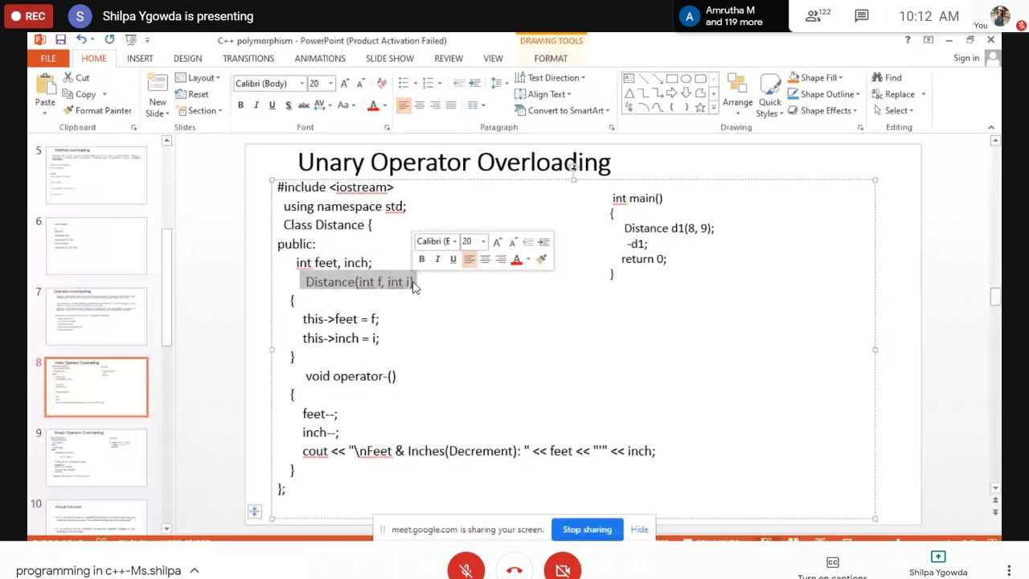

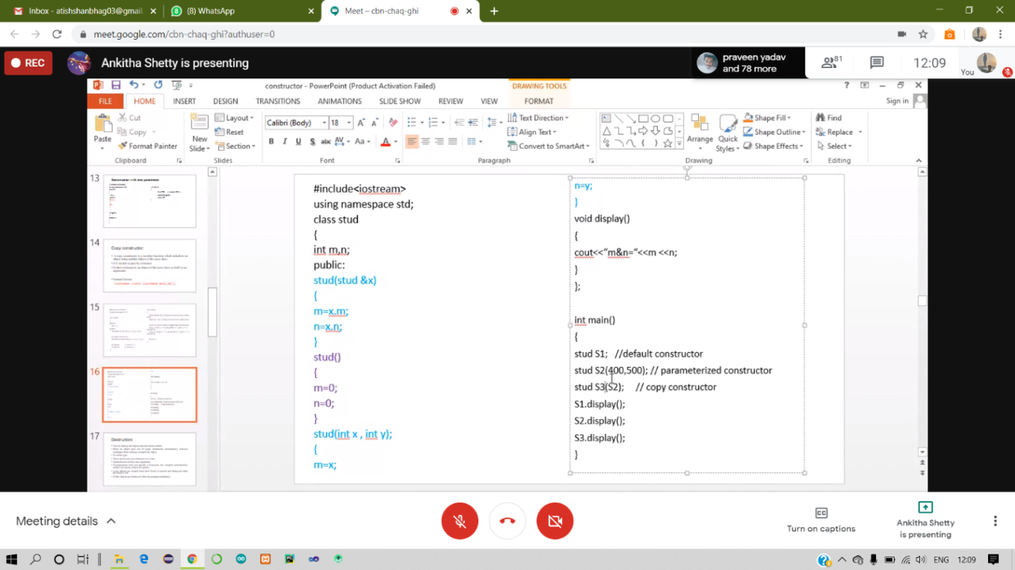

**Coding challenges :**

1. Java program to find the first non repeated character of a given String.

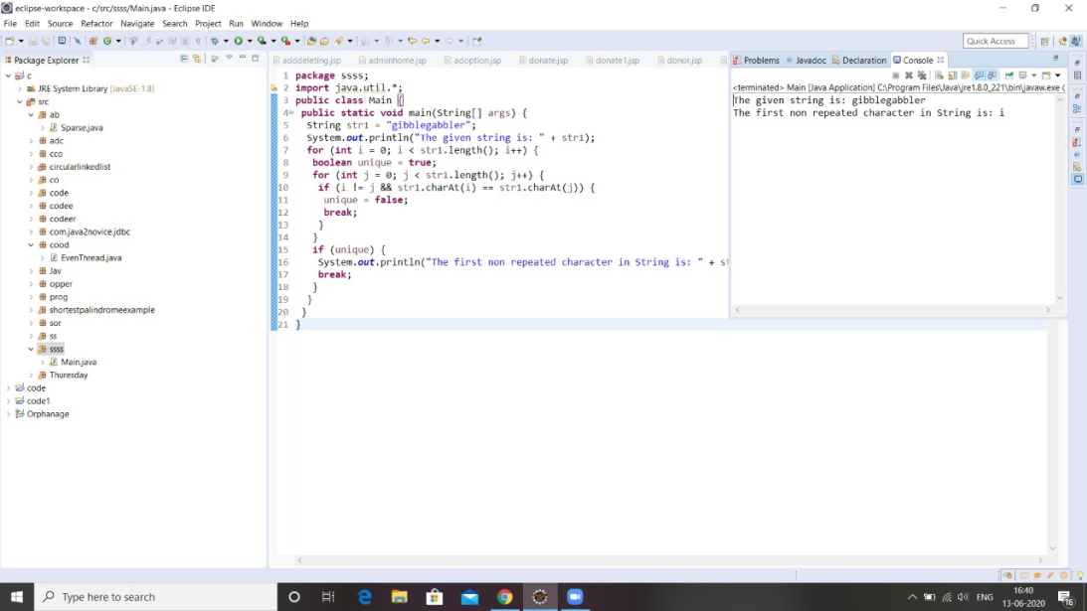

2. Python Program to print the pattern of alphabets.

